**HIVE JOBS:**

1. **Customer Segmentation**

Categorizing customers based on their spendings

**SELECT customer_id,**

**CASE**

**WHEN total_spending < 1000 THEN 'Low Spending'**

**WHEN total_spending >= 1000 AND total_spending < 5000 THEN 'Moderate Spending'**

**WHEN total_spending >= 5000 THEN 'High Spending'**

**ELSE 'Unknown'**

**END AS spending_segment**

**FROM (SELECT customer_id, SUM(payment) AS total_spending FROM ecommerce_sales GROUP BY customer_id) AS total_spending_by_customer;**

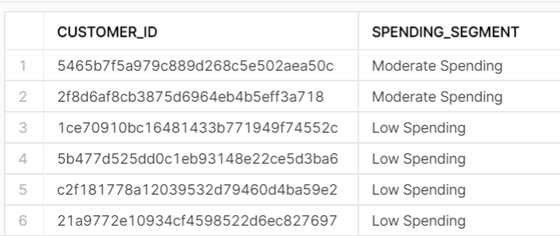

2. **Monthly Trend Forecasting**

the monthly trend of sales

**SELECT year(timestamp) as year,month(timestamp) AS month, SUM(payment) AS total_sales**

**FROM ecommerce_sales GROUP BY year,month(timestamp)**

**ORDER BY year, month;**

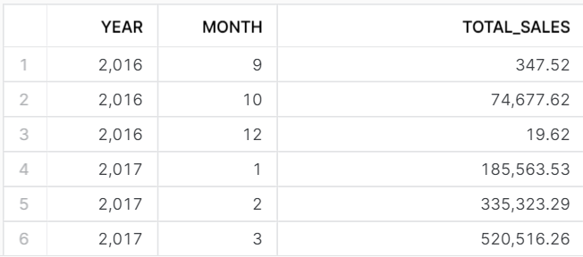

3. **Hourly Sales Analysis**

Which hour has more no. of sales?

**select extract(hour,timestamp) as Hour, count(order_id) as cnt from ecommerce_sales**

**group by Hour order by cnt desc limit 10;**

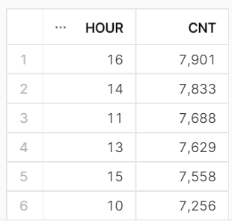

1. **Product Based Analysis**

Which category product has sold more?

**select product_category, count(order_id) as Total_sales from ecommerce_sales**

**group by product_category order by Total_sales desc limit 10;**

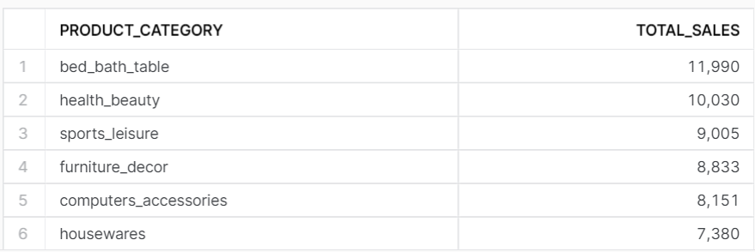

Which category product has more rating?

**select product_category, count(order_id) as Total_sales from ecommerce_sales**

**group by product_category order by Total_sales desc limit 10;**

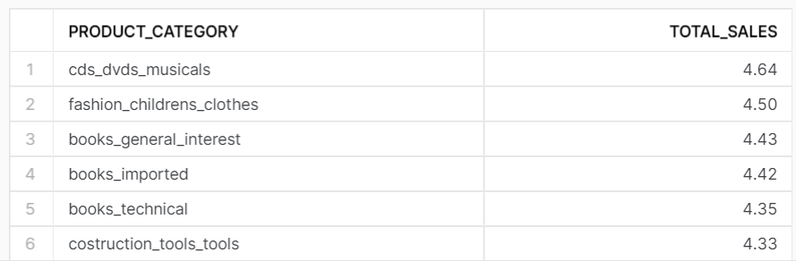

Which product has sold more?

**select product_id, count(order_id) as Total_sales from ecommerce_sales**

**group by product_id order by Total_sales desc limit 10;**

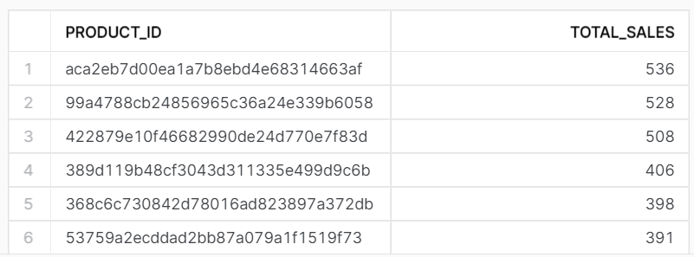

Top 10 highest & least product rating?

**with cte1 as**

**(select product_category, round(avg(rating),2) as Total_sales from ecommerce_sales**

**group by product_category order by Total_sales desc limit 10),**

**cte2 as(select product_category, round(avg(rating),2) as Total_sales from ecommerce_sales**

**group by product_category order by Total_sales asc limit 10)**

**select * from cte1**

**union**

**select * from cte2;**

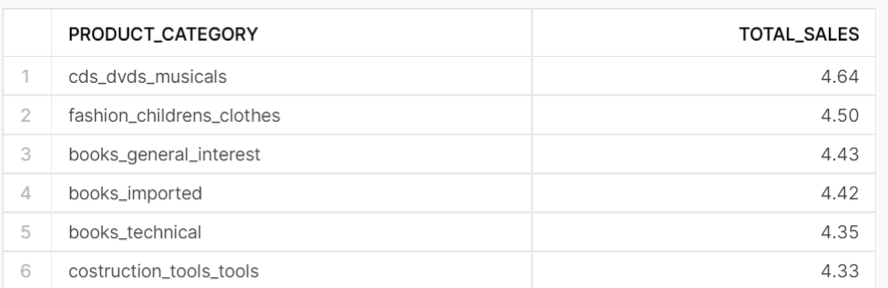

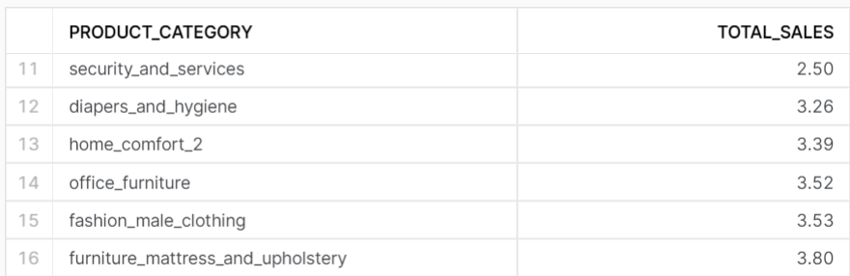

Order Count for each rating?

**select rating, count(order_id) as order_count from ecommerce_sales**

**group by rating order by order_count desc;**

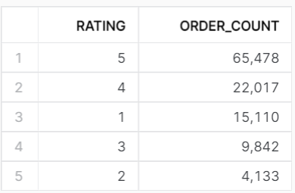

5. **Payment Preference**

What are the most commonly used payment types?

**select payment_type, count(order_id) as cnt from ecommerce_sales**

**group by payment_type order by cnt desc limit 2;**

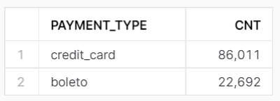

Count of Orders With each No. of Payment Installments?

**select payment_installments, count(order_id) as cnt from ecommerce_sales**

**group by payment_installments order by cnt desc;**

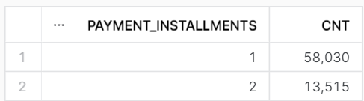

6. **Potential Customer's Location**

Where do most customers come from?

**select customer_city, count(order_id) as cnt from ecommerce_sales**

**group by customer_city order by cnt desc limit 10;**

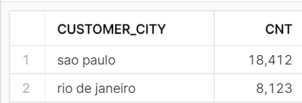

7. **Seller Rating**

Which seller sold more?

**select seller_id, count(order_id) as cnt from ecommerce_sales**

**group by seller_id order by cnt desc limit 10;**

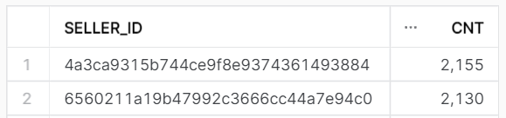

Which seller got more rating?

**select seller_id, round(avg(rating),2) as avg_rating, count(rating) as number_of_rating from ecommerce_sales**

**group by seller_id order by number_of_rating desc,avg_rating desc;**

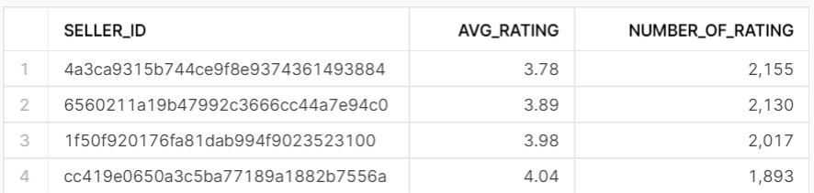

8. **Logistics based Optimization Insights**

Which city buys heavy weight products and low weight products?

**with cte1 as**

**(select customer_city,product_weight_g from ecommerce_sales order by product_weight_g desc limit 1),**

**cte2 as**

**(select customer_city,product_weight_g from ecommerce_sales order by product_weight_g asc limit 1)**

**select * from cte1**

**union all**

**select* from cte2;**

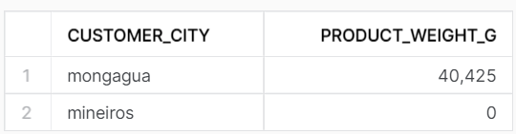

How much products sold within seller state?

**select seller_state, sum(quantity) as products_sold from ecommerce_sales group by 1 order by 2 desc;**

